Census Tool/ Demographics

# Geohive

<http://census2016.geohive.ie/>

OSI & CSO

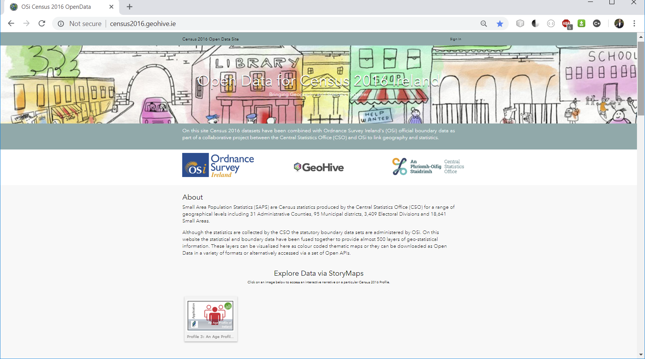

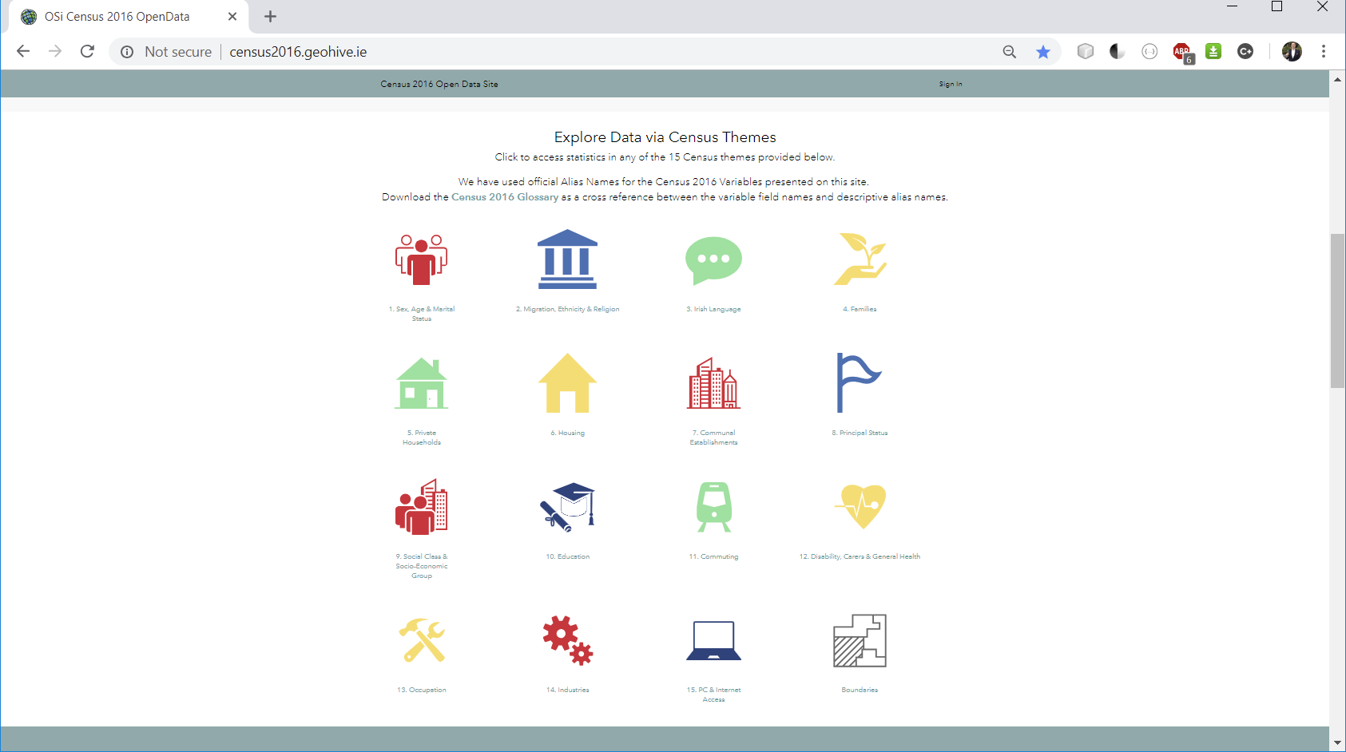

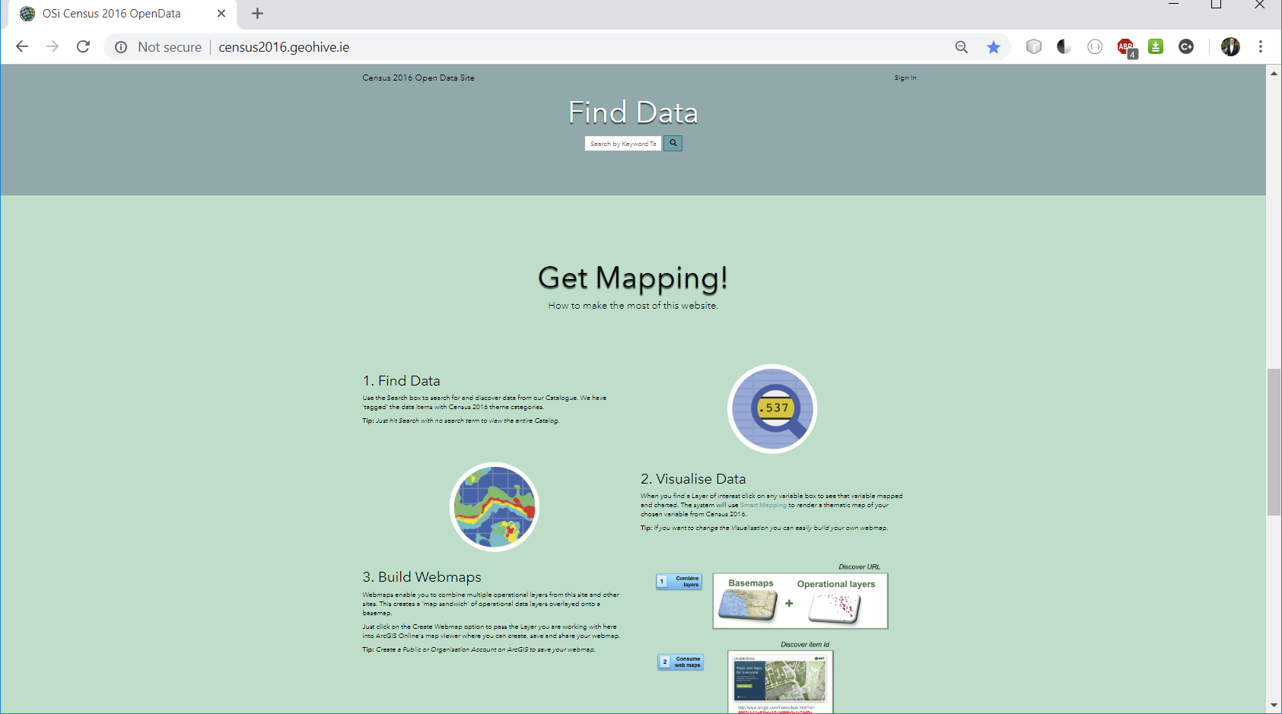

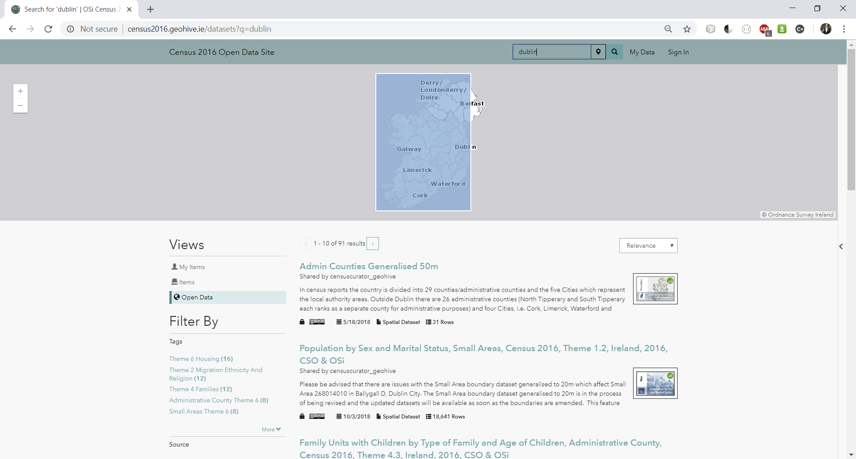

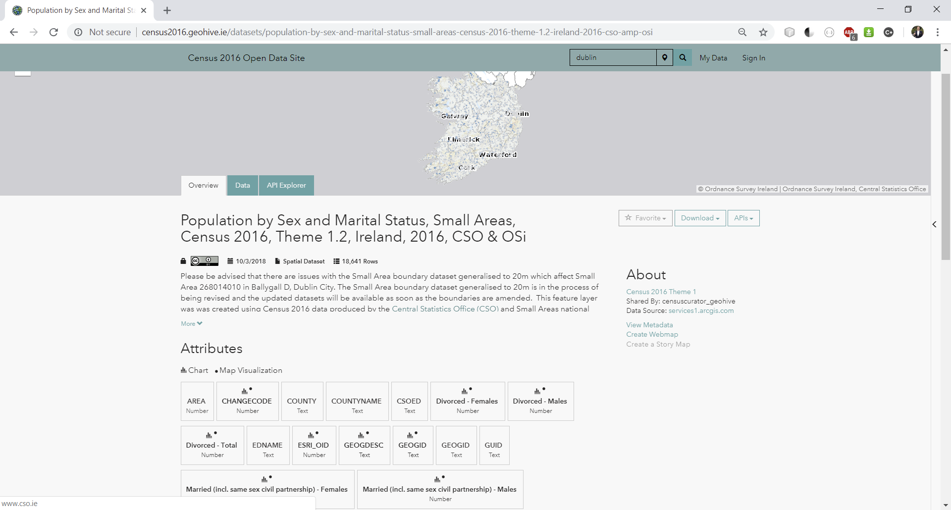

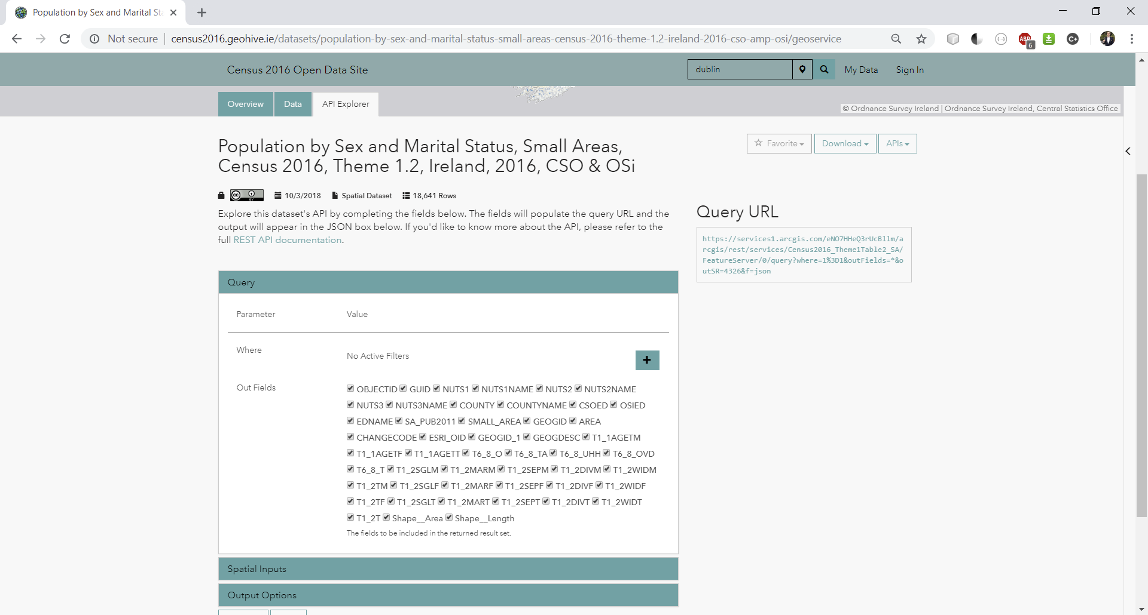

[https://services1.arcgis.com/eNO7HHeQ3rUcBllm/arcgis/rest/services/Census2016_Theme1Table2_SA/FeatureServer/0/query?where=1%3D1&outFields=*&outSR=4326&f=json](https://services1.arcgis.com/eNO7HHeQ3rUcBllm/arcgis/rest/services/Census2016_Theme1Table2_SA/FeatureServer/0/query?where=1%3D1&outFields=*&outSR=4326&f=json)

* Improvement on this- load the glossary and use multiselect drop down to compare variables
* 15 Themes, multiple tables on each
* Return data from search rather than loading the whole datasets

How to:

Indicate the themes and tables that are available?

Allow selection of themes/ tables?

Allow comparisons of themes/tables?

Some problems

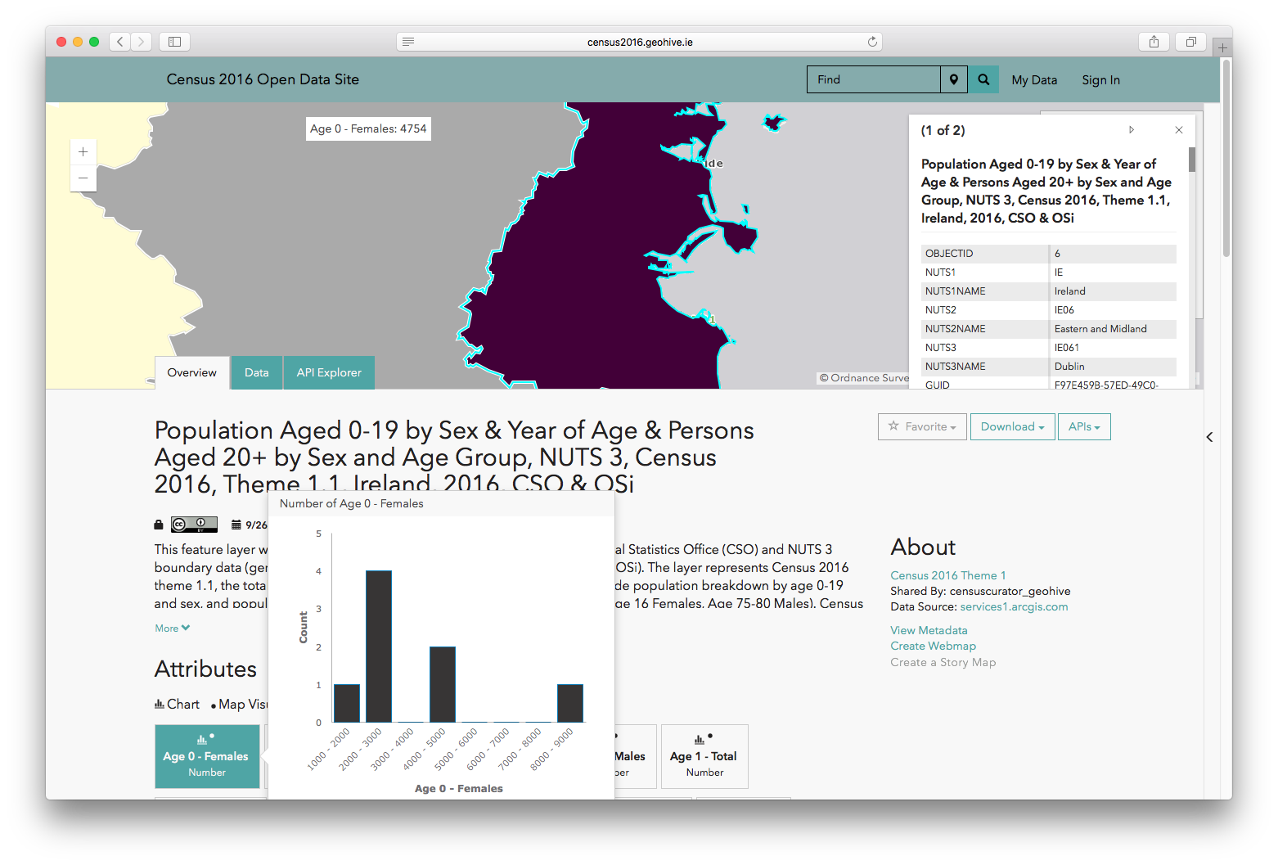

Can’t select multiple attributes

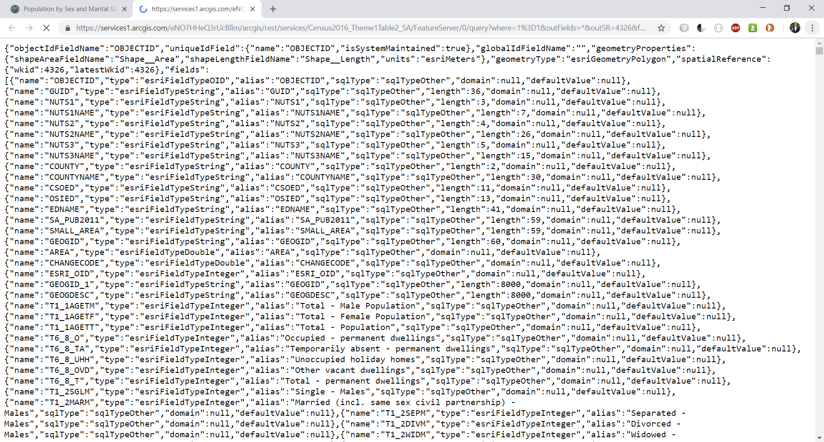

API ref https://developers.arcgis.com/rest/services-reference/query-feature-service-layer-.htm

Maintained by ESRI

## ID blog- mapping census data

see pdf in /Users/losullivan/Google Drive/NCG/Tasks/New Dashboard Visualisations/Demographics/Research

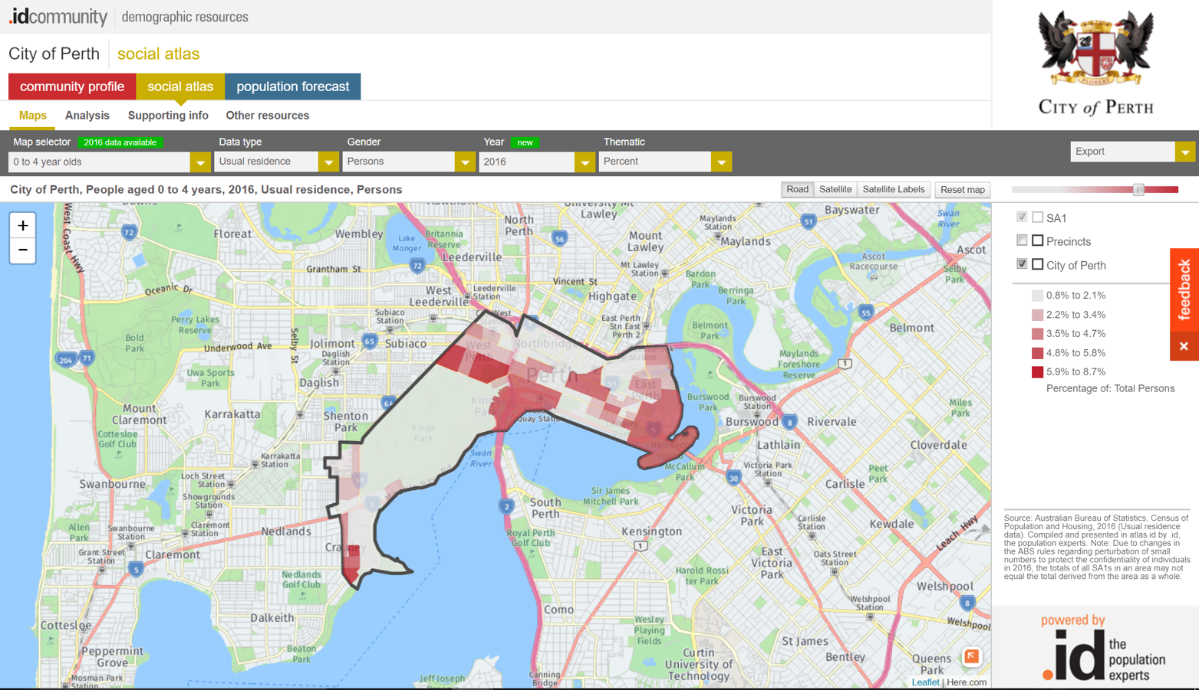

# SA Maps/ Demographics

There’s a limit of 1000 records output

Use 4326 as out SR

<https://www.cso.ie/en/census/census2016reports/census2016smallareapopulationstatistics/>

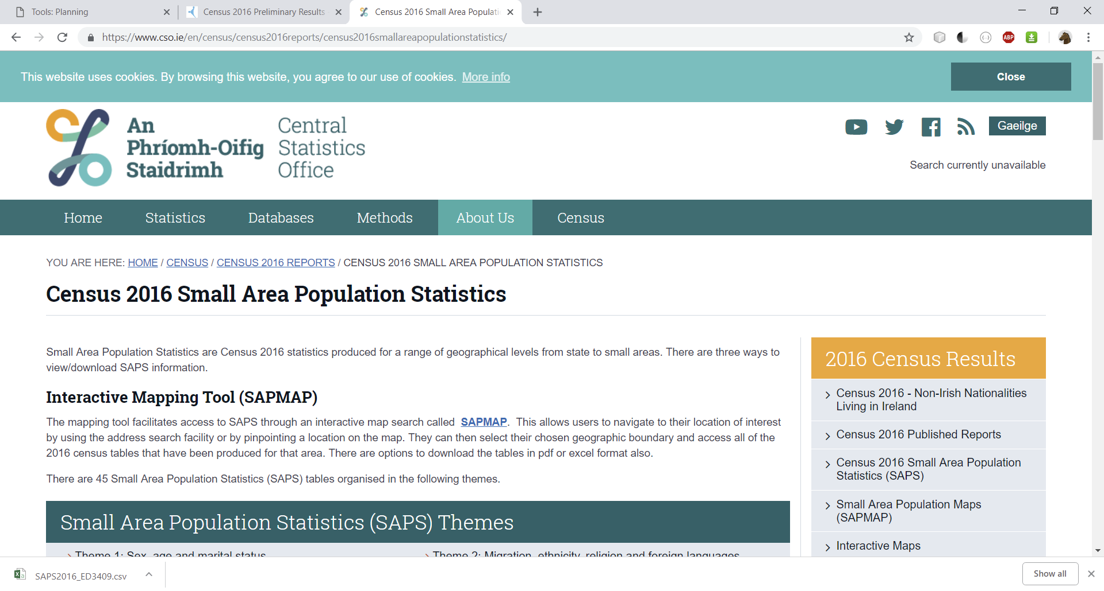

See the SAPS manual

How much to replicate from their map?

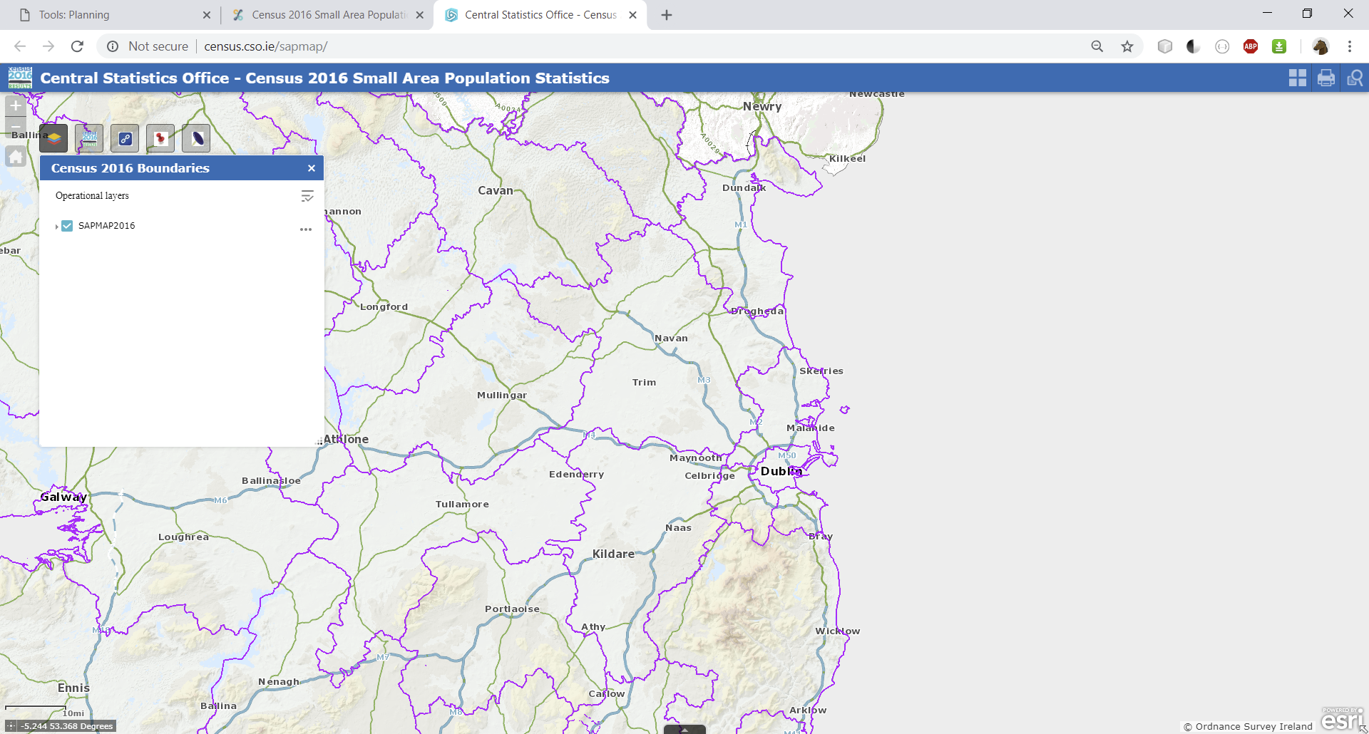

SmallAreas… geojson contains the boundaries and the identifiers

SAPS2016_CTY contains the data for administrive counties i.e. LAs

Data organised into themes codes e.e T3_2DOES described in the Glossary

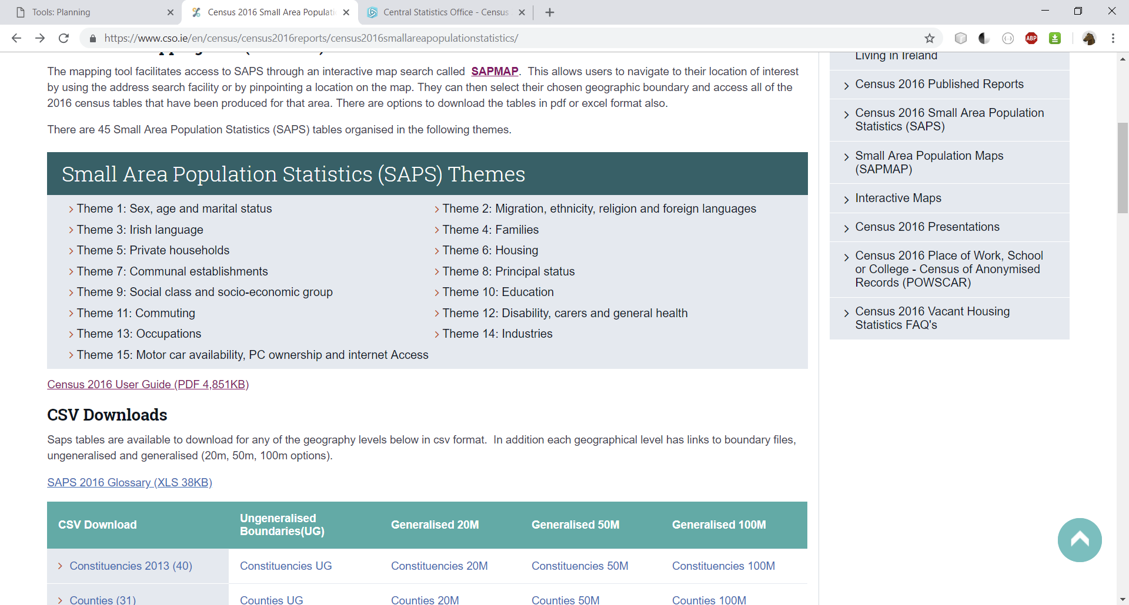

The SA number in the boundary file maps to the GEOGID in the SAPS csv

Add housing data themes to planning map

# Database

# API

Express model -> API for SFI Audit

Shiffman: <https://youtu.be/P-Upi9TMrBk?list=PLRqwX-V7Uu6Yyn-fBtGHfN0_xCtBwUkBp>

* Server-side reasons:
  + Large data
  + Persistence
  + Expose API
  + CORS/ scraping from server by server

# Handling large data

Census data -> 1GB in browser

#1

Filter geojson by County and export goejson/ topojson, then filter data variables only by GEOGID. Gives 1 reduced geojson of boundaries and 1 reduced csv.

Small_Areas__Generalised_20m__OSi_National_Boundaries.geojson ~38MB on disk

SAPS2016_SA2017.csv ~38 MB

Basic node app at C:\Users\Liam\Google Drive\NCG\Research_Learning\Software Development\Javascript\Node\NodeJSTestApp

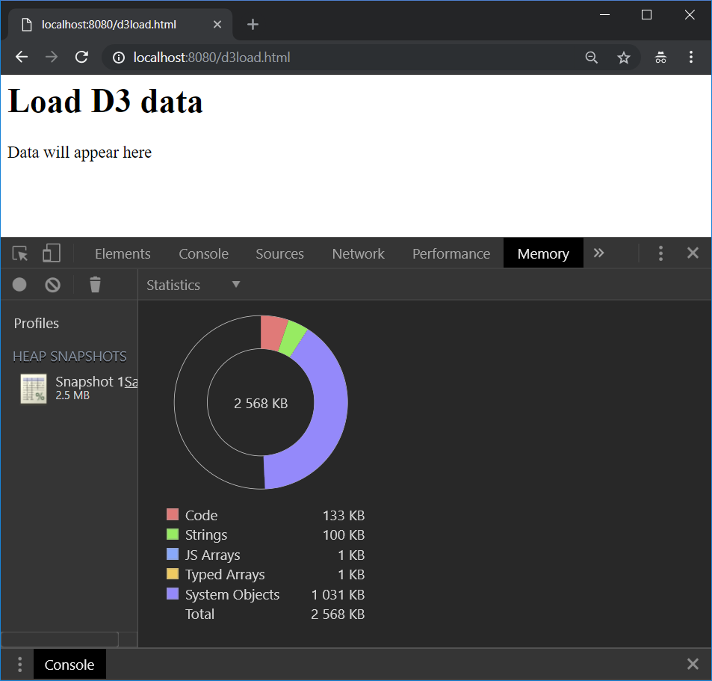

With d3.js lib in head script

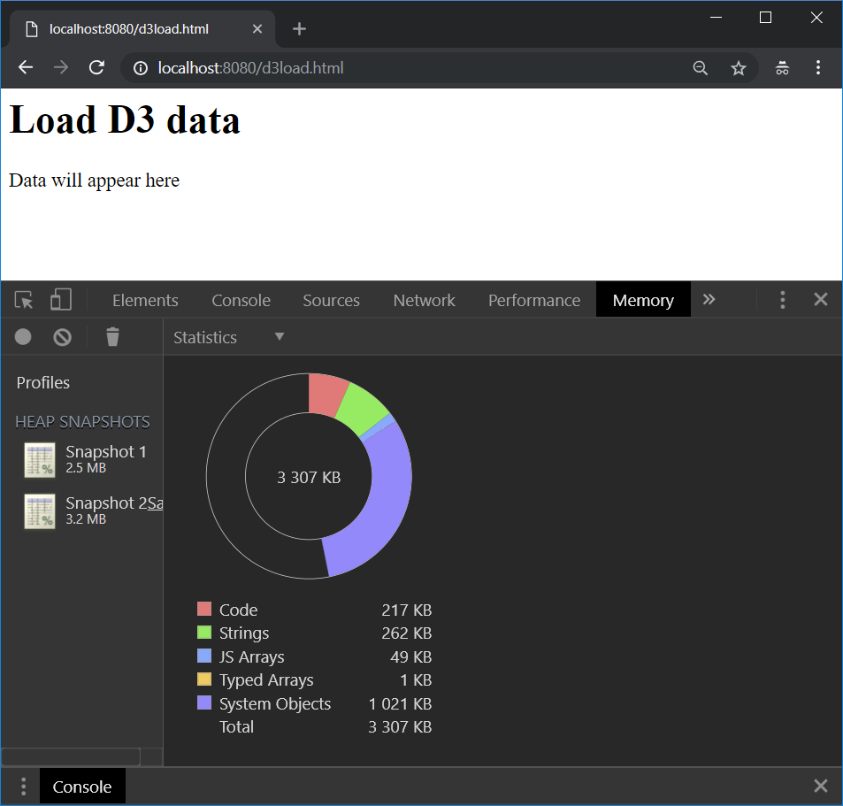

d3.csv("SAPS2016_SA2017.csv").then(function (data) {

console.log("data loaded");

});

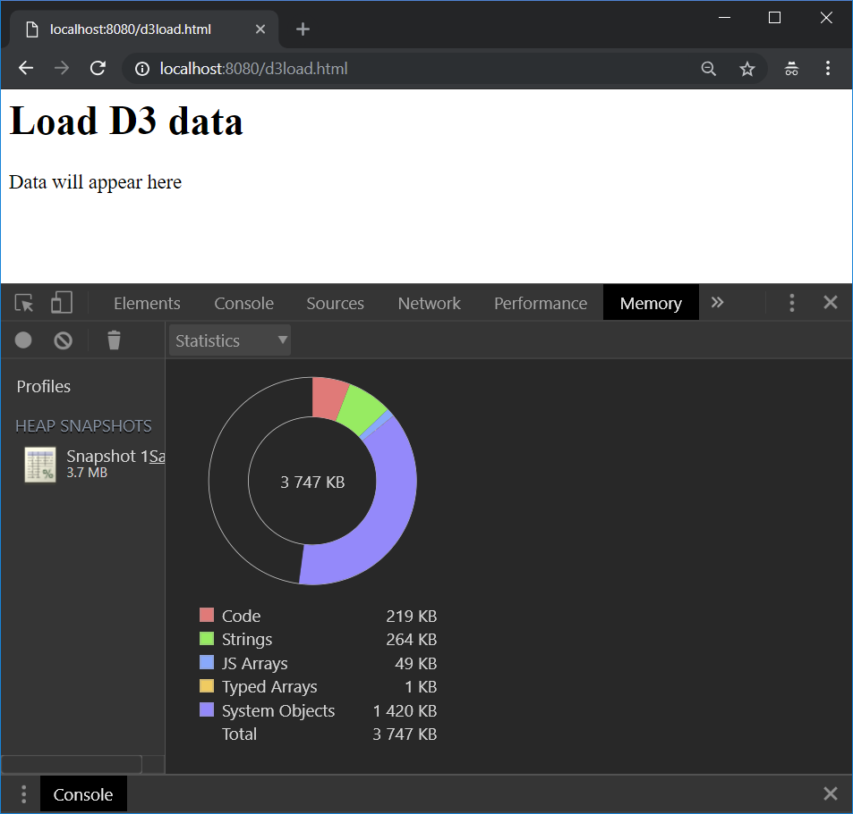

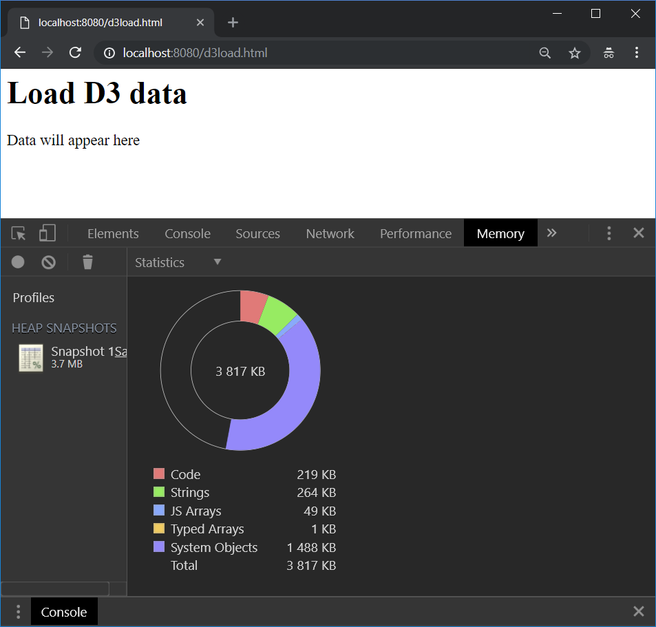

<script src="https://cdnjs.cloudflare.com/ajax/libs/crossfilter/1.3.12/crossfilter.min.js">

</script>

let censusDataXF = crossfilter(data_);

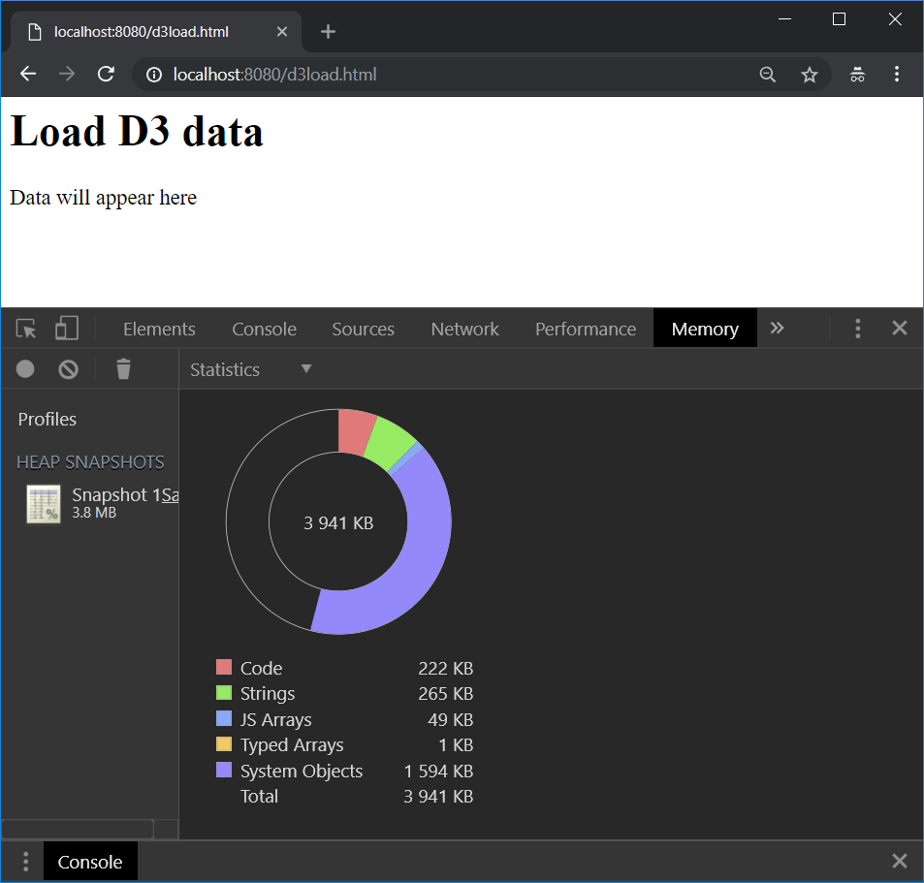

let idDim = censusDataXF.dimension(function (d) {

return +d.GEOGID.split('_')[1];

});

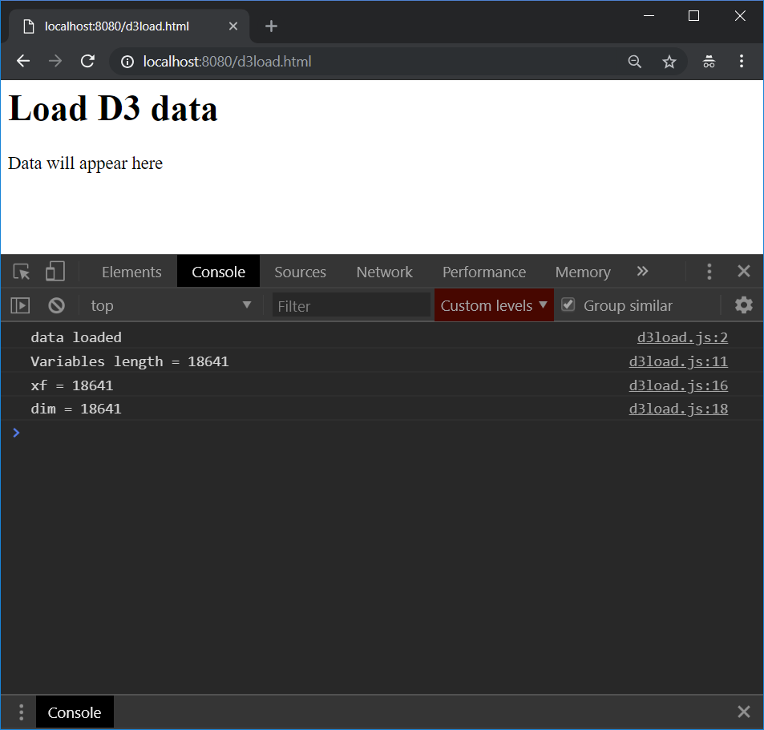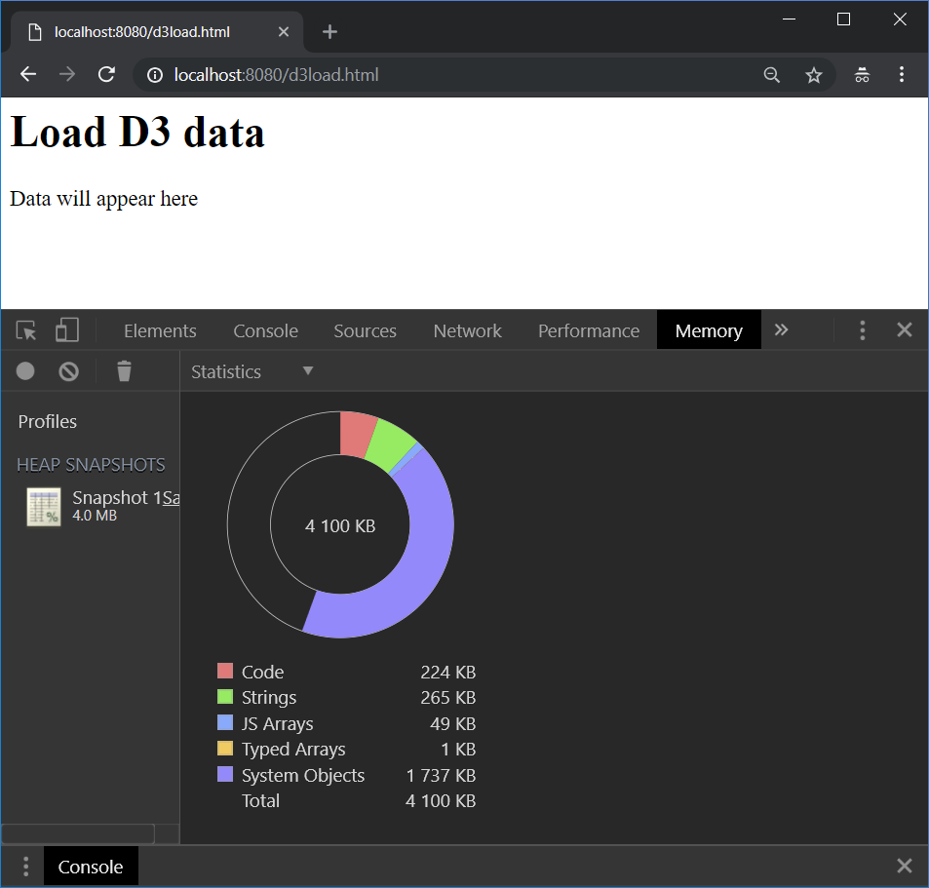

d3.select("#data").html("<p> The first data element is:<p>"

+JSON.stringify(idDim.top("Infinity")[0]));

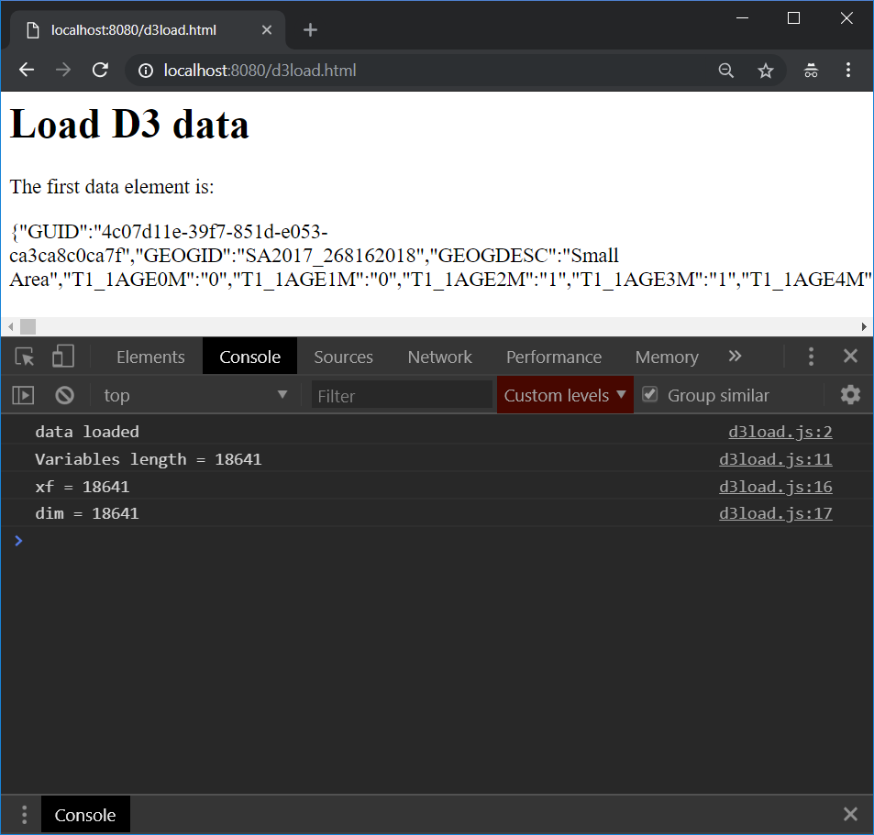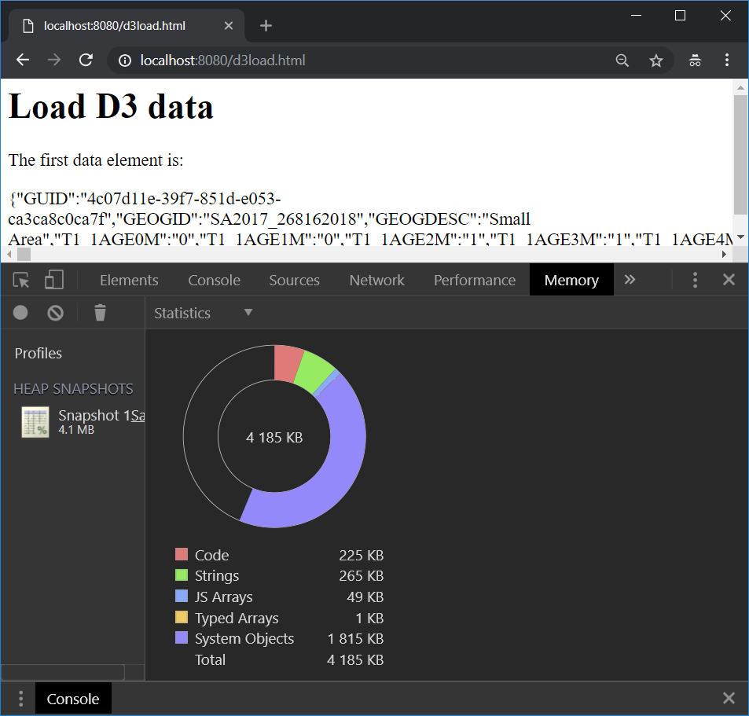

Azure site performance

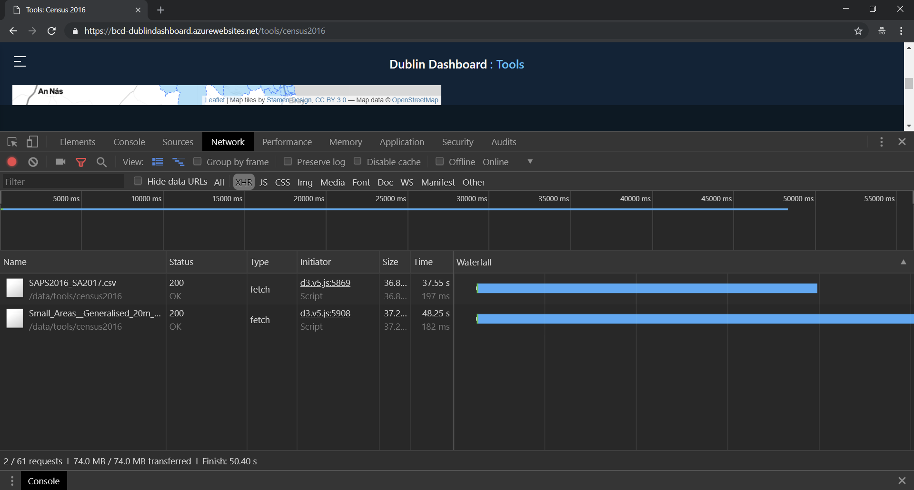

Query geojson api

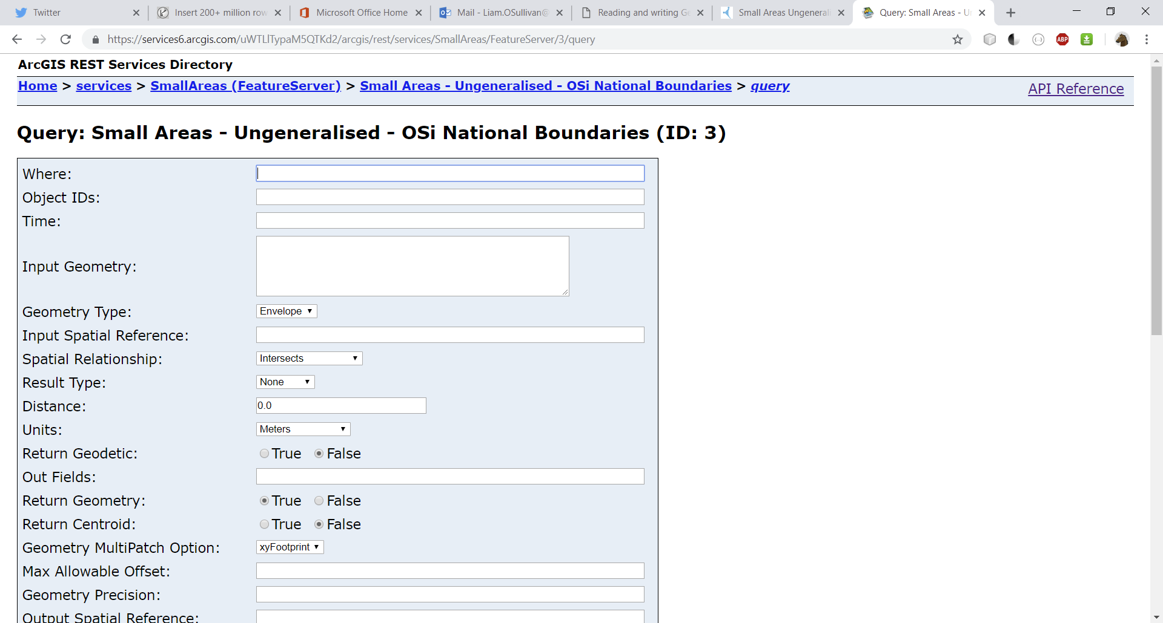

WHERE COUNTYNAME LIKE '%Dublin%' OR COUNTYNAME LIKE '%Fingal%' OR COUNTYNAME LIKE '%Rathdown%'

# Development

## Product backlog

* Area selection
* Find address/ location

## Locative service

### Address lookup

<https://nominatim.openstreetmap.org/>

Fair usage: <https://operations.osmfoundation.org/policies/nominatim/>

Requires ability to disable without software update or patch ***How to do this and other admin tasks on Node via control panel or similar?

<https://wiki.openstreetmap.org/wiki/Nominatim/Installation>

Example:

https://nominatim.openstreetmap.org/search?q=135+pilkington+avenue,+birmingham&format=xml&polygon=1&addressdetails=1

<https://nominatim.openstreetmap.org/search?q=devenish+road,+dublin&format=geojson&polygon=1&addressdetails=1>

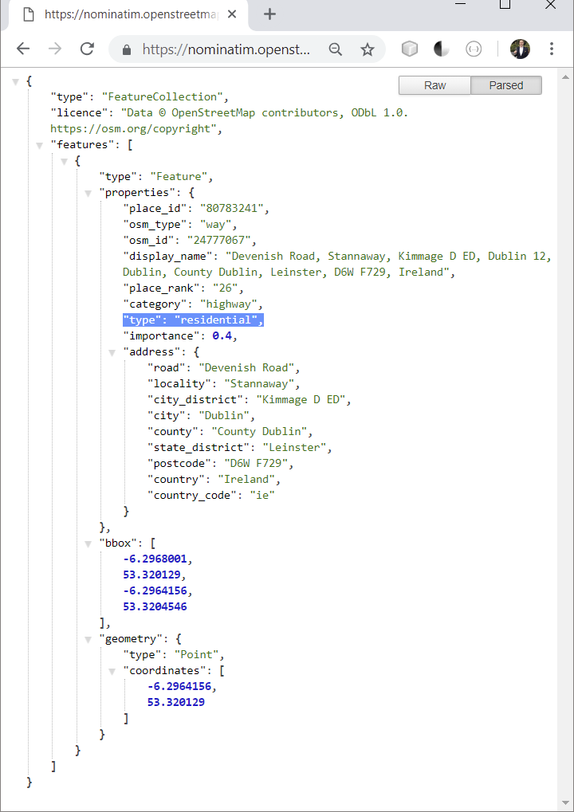

### ‘Find me’

https://github.com/domoritz/leaflet-locatecontrol